Controller of mini heat pump user manual
- Wire controller
  - Wire control interface
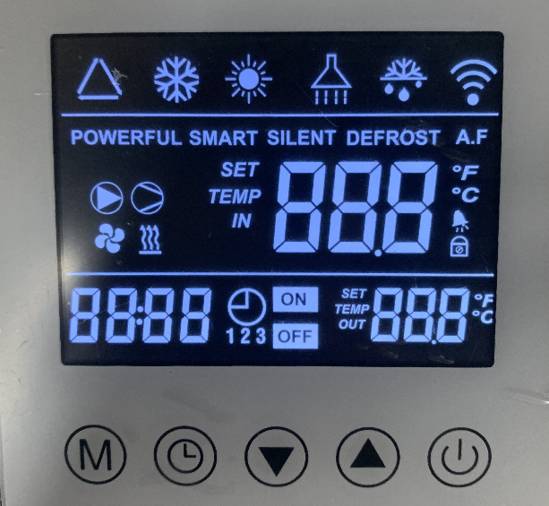

1.2 Key Definition and Operation：
1.2.1“”on/off key：
  - On/off key；
  - On the main interface, press this button to turn on or off the heat pump；
  - In the parameter interface and parameter setting interface, press this key to return to the main interface；
  - On the main interface, press and hold this button for 3 seconds to unlock or lock the screen

1.2.2“”function key：
  - Function key
  - On the main interface of the power on, press the "Function" button to switch between working modes

1.2.3“”and“”：
  - Up and down key；
  - On the main interface, the two keys can be used to adjust the current set temperature；

1.2.4“”Timer key：
  - Long press and hold the "timer" button for 3 seconds to enter the real-time clock setting interface. When entering the real-time clock setting interface, the hour and minute positions will flash together. Press the timer button again, the hour position will flash and the minute position will remain on. At this time, cooperate with the up and down keys to adjust the hour position. After adjusting the hour position, press the timer button again, the hour position will remain on and the minute position will flash. At this time, cooperate with the up and down keys to adjust the minute position. After adjusting the minute position, press the timer button again to confirm and return to the main interface.
  - Press the "timer" button to enter the timing setting interface. At this time, timing group 1 flashes (you can select the timing group through the up and down keys). When the current timing group is selected, the timing group flashes. At this time, press the timer button to enter the current timing group setting. Use the timing button to switch timing time bits. The order is the hour bit for timing on, the minute bit for timing on, the hour bit for timing off, and the minute bit for timing off. After adjusting with the up and down keys, Press the timer key again to return to the timer group 2 interface. After repeating the above operation, return to the main interface. The current timer group flashes. At this time, long press the timer key, and ON/OFF will light up, indicating that the current timer group is valid.

1.2.5 Resst：
  - Pressing and holding the “”key and “”key together for 10 seconds can restore the default values of the parameters；

1.2.6 Forced defrosting：
  - Long press and hold“”+“”for 10 seconds to enter forced defrosting;

1.2.7 Status Query：
  - Long press and hold “”+“”for 5 seconds, collaborate with up and down keys to query running parameters

1.2.8 Parameter settings：
  - In the shutdown state, press and hold the “”+“” for 10 seconds, combined with the up and down keys, to set various parameters

1.2.9 Conversion between Celsius and Fahrenheit：
  - Press and hold“”+“”together for 3 seconds allows for conversion between Fahrenheit and Celsius degrees, with Celsius degrees displayed by default

System protection
  - Water flow fault
  - After running the water pump for 10 seconds, if the water flow switch is detected to be disconnected for 2 consecutive seconds, it is judged as a water flow fault and the entire machine is shut down. After a water flow fault occurs, it can automatically recover. Do not shield this fault during defrosting. (After a water flow fault occurs, the water pump automatically cycles and starts, detecting the water flow switch until it is closed) Cycle every 2 minutes and 30 seconds
  - The remote control displays FFF

  - Winter antifreeze protection
  - Detect the inlet temperature T_{IN} and ambient temperature T_{W} in standby mode
  - When T_{IN}＜15℃ and T_{W}≤0℃，enter the first level antifreeze state, and the unit will automatically start and operate the water pump mode; when T_{IN}>15℃ or T_{W}≥2℃, exit the antifreeze process。
  - If T_{IN}≤2℃ and T_{W}≤0℃，enter the second level antifreeze state, and the unit will automatically start and operate in heating mode; until T_{IN}>15℃ or T_{W}≥2℃，exit the antifreeze process.
  - If T_{W} malfunctions, it is up to T_{IN} to decide whether to prevent freezing. If T_{IN} malfunctions, T_{W} decides whether to prevent freezing (T_{IN} malfunctions can only enter first level antifreeze). If both T_{IN} and T_{W} malfunctions, the antifreeze function will not be processed.
  - The remote control displays AFP

2.3 Water inlet temperature sensor fault
  - If a short circuit or open circuit is detected in the water inlet temperature sensor, it is judged as a water inlet temperature sensor fault and the system is shut down for protection.
  - The remote control display PP 1。
  - Discharge temperature sensor fault
  - If a short circuit or open circuit is detected for discharge temperature sensor, it is judged as an discharge temperature sensor fault and the system is shut down for protection.
  - The remote control display PP 2。
  - Coil temperature sensor fault
  - If a coil temperature sensor short circuit or open circuit is detected, it is judged as a coil temperature sensor fault.
  - The remote control display PP 3。
  - Ambient temperature sensor fault
  - If an ambient temperature sensor short circuit or open circuit is detected, it is judged as an ambient temperature sensor fault, and the corresponding antifreeze conditions are cancelled, and the system continues to operate as usual.
  - The remote control display PP 5。
  - Low pressure protection
  - After the system compressor is started for 5 minutes, when the low pressure switch of the system is detected to be disconnected for 10 consecutive seconds, it enters low pressure protection; When the low pressure switch is detected to be closed, the low pressure protection will exit. When this fault occurs three times within 30 minutes, it cannot be restored unless it is powered off.
  - Shield this fault during defrosting.
  - The remote control display EE 2。
  - Discharge temperature is too high protection
  - After the compressor is started for 1 minute, if the discharge temperature is detected to be ≥ 95 ℃ (parameter P09, adjustable), it is judged that the discharge temperature is too high. Stop the machine and display EE5. When the discharge temperature is detected to be ≤ 95-15 (i.e. the discharge temperature difference is 15)=80 ℃, it is displayed normally and the discharge too high protection is exited. The compressor has a 3-minute shutdown protection.
  - When this fault occurs three times within 30 minutes, it cannot be restored unless it is powered off.
  - The remote control display EE5
  - Communication failure
  - If the motherboard has not received a communication signal from the remote controller within 20 seconds of the first power on, it is considered as disconnected from the remote controller. The system does not indicate, and at this time, the system only controls operation based on the mode switch signal.
  - If the motherboard is connected to a remote controller, but the remote controller does not receive the motherboard status signal for 10 consecutive seconds, it is judged as a communication fault.
  - The remote control display EE 6。

  - Fault Code Table
System malfunction：
Protection/ Fault | Wire controller
Standby
Normal startup
Water inlet temperature sensor fault | PP 1
Discharge temperature sensor fault | PP 2
Coil temperature sensor fault | PP 3
Ambient temperature sensor fault | PP 5
Winter first level antifreeze protection | AFP
Winter second level antifreeze protection | AFP
Water flow fault | FFF
High pressure protection | EE 1
Low pressure protection | EE 2
Discharge temperature too high protection | EE 5
phase-sequence protection | EE 4
Communication failure | EE 6
Defrosting | Defrost indication

- System parameters：
Parameter | Meaning | Range | Default | Remark
P01 | Cooling inlet water temperature setting range | 3～45℃(50℉～113℉) | 27(81℉) | adjustable
P02 | Heating inlet water temperature setting range | 3～45℃(50℉～113℉) | 27(81℉) | adjustable
P03 | Defrost cycle | 30～90Min | 45 | adjustable
P04 | Defrost entry temperature | 0～-30℃(32℉～-22℉) | -7(19℉) | adjustable
P05 | Exit defrosting temperature | 2～30℃(36℉～-86℉) | 13(55℉) | adjustable
P06 | Exit defrosting time period | 1～12Min | 5 | adjustable
P07 | Model (single cooling/heat pump/single heating) | - single cooling  - heating and cooling  - single heating | 0 | adjustable
P08 | Automatic inlet water temperature setting value | 3～45℃(50℉～113℉) | 27(81℉) | adjustable
P09 | Discharge temperature protection value | 85～110℃(185℉～230℉) | 95(203℉) | adjustable
P10 | Water pump operation mode | 0(ordinary)/1（special） | 1 | adjustable
P11 | Differential setting temperature | 1～4℃(2℉～7℉) | 1(2℉) | adjustable
P12 | Differential setting temperature | 30～50℃(86℉～122℉) | 40(104℉) | adjustable
P13 | Target temperature difference between heating discharge and inlet water | 5～100 | 35(63℉) | adjustable
P14 | Cooling electronic expansion valve exhaust regulating temperature | 80～120 | 95(203℉) | adjustable
P15 | Steps of cooling electronic expansion valve under condition 0 (y0) | 100～500 | 250 | adjustable
P16 | Steps of cooling electronic expansion valve under condition 1 (y1) | 100～500 | 400 | adjustable
P17 | Steps of cooling electronic expansion valve under condition 2 (y2) | 100～500 | 480 | adjustable
P18 | Steps of cooling electronic expansion valve under condition 3 (y3) | 100～500 | 300 | adjustable
P19 | Steps of cooling electronic expansion valve under condition 4 (y4) | 100～500 | 400 | adjustable
P20 | Steps of cooling electronic expansion valve under condition 5 (y5) | 100～500 | 480 | adjustable
P21 | Steps of cooling electronic expansion valve under condition 6 (y6) | 100～500 | 350 | adjustable
P22 | Steps of cooling electronic expansion valve under condition 7 (y7) | 100～500 | 450 | adjustable
P23 | Steps of cooling electronic expansion valve under condition 8 (y8) | 100～500 | 480 | adjustable
P24 | Steps of electronic expansion valve when defrosting | 100～500 | 400 | adjustable

- System Status Query：
A01 | Inlet water temperature | -9～99℃ |  | Measured value
A02 | Discharge temperature | -9～99℃ |  | Measured value
A03 | Coil temperature | -9～99℃ |  | Measured value
A04 | Ambient temperature | -9～99℃ |  | Measured value
A05 | Steps of electronic expansion valve | 0～500 |  | Measured value

